**Basic bodybuilding splits.**

Many types of training styles will get different results, body building splits typically have a focus on medium to high rep ranges. Even within the different goals, there are different ways to achieve them, here are a few different bodybuilding training splits.

Dreamstime.com. (2023). Available at: https://thumbs.dreamstime.com/b/nova-scotia-bodybuilder-wins-toronto-bodybuilder-chris-bumstead-new-brunswick-canada-showed-off-outstanding-powerful-94143573.jpg [Accessed 14 Feb. 2023].

**PPL(Push pull legs)**

Push, pull, legs is a common training split for those who only want to train 3 times a week, or even want to train 6 times a week as it allows for each body part to be hit twice with good volume. Here's a typical week if you only trained 3 times:

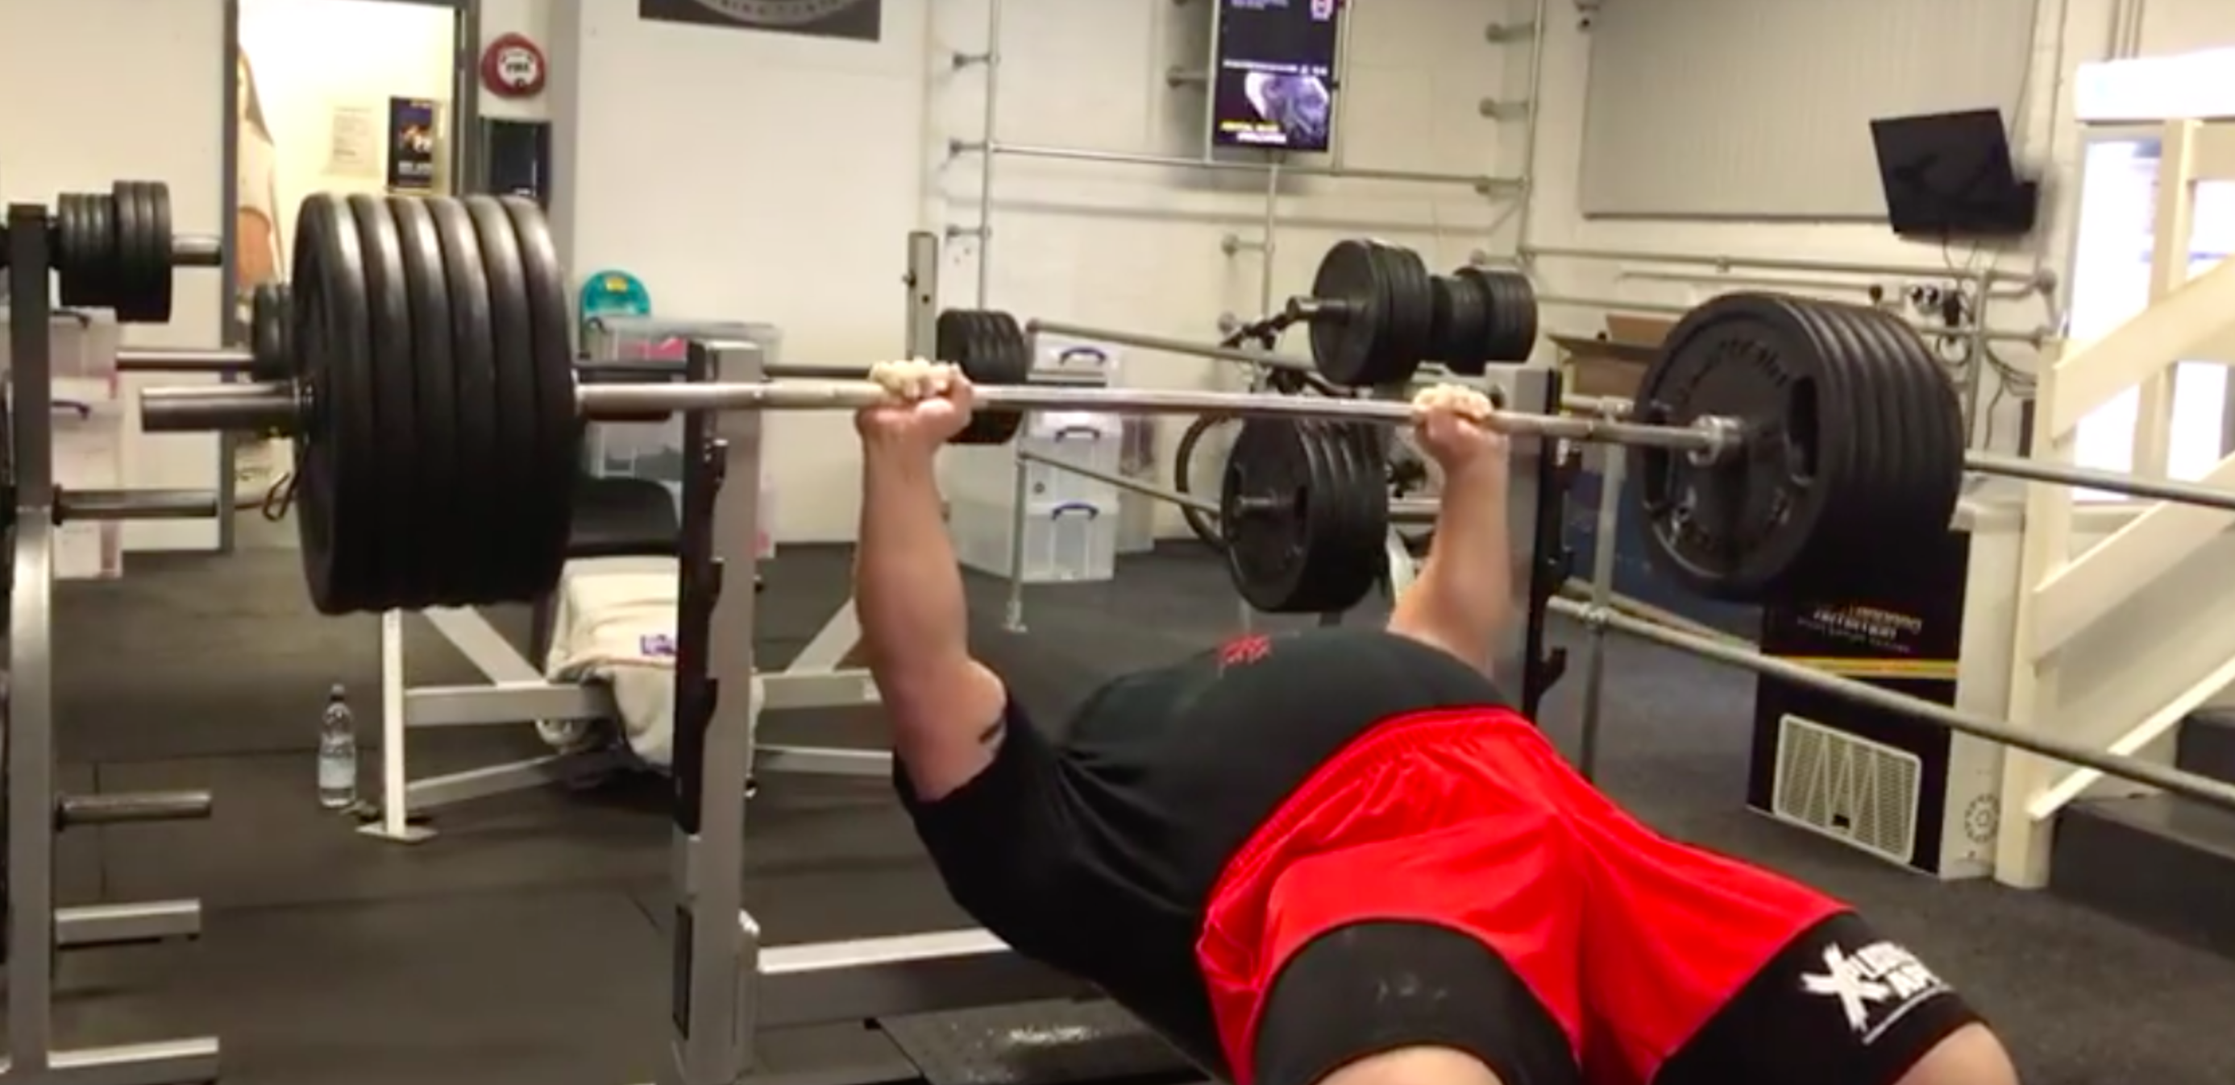

www.youtube.com. (n.d.). *Eddie Hall 265kg Bench Press at Strength Asylum*. [online] Available at: https://youtu.be/74nhtcP1Ur0 [Accessed 14 Feb. 2023].

**Monday**

*Push day.*

1. Benchpress
2. Incline dumbbell press
3. Machine shoulder press
4. Lateral raises
5. Tricep pushdowns

**Wednesday**

*Pull Day*

1. Bent over rows

2. Lat pull downs

3. Machine row

4. Dumbbell shrugs

5. Preacher curls (ez bar)

6. Cable curls

**Friday**

*Legs*

1. Squats

2. Leg press

3. Bulgarian split squats

4. Hamstring curls

5. Romanian deadlifts

6. Calf Raises

**Arnold Split**

Named after the legendary Arnold Schwarzenegger, this training style involves training opposite muscles to optimize the “pump” that is gotten. A typical week would look like this:

<https://fitbod.me/blog/arnold-split/#:~:text=The%20Arnold%20split%20is%20a,it's%20only%20for%20advanced%20lifters>.

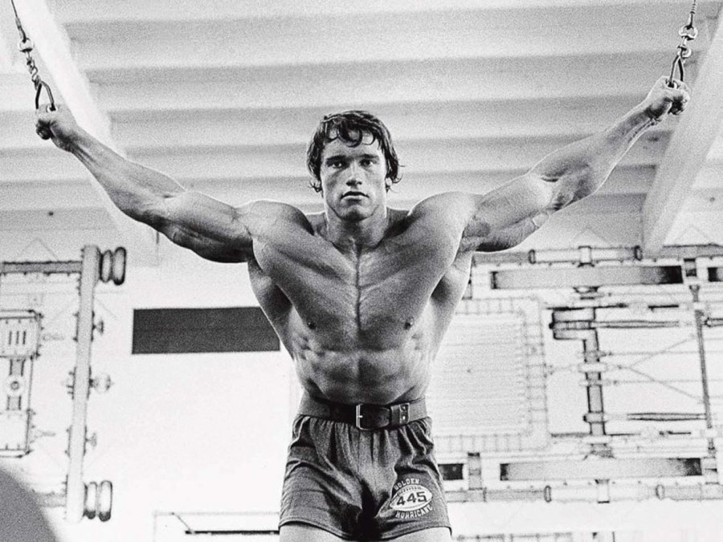

(2023). Ironmanmagazine.com. <https://www.ironmanmagazine.com/wp-content/uploads/arnold-Workout.jpeg>

**Monday**

*Chest and back*

1. Dumbbell bench press
2. Lat pull down
3. Low to high cable flies
4. Seated cable row
5. Chest dips(weighted or assisted if required)
6. Dumbbell rows

**Tuesday**

*Arms/Shoulders*

1. Straight bar curl
2. Barbell shoulder press
3. Overhead tricep extension
4. Preacher curl
5. Lateral raises
6. Cable pushdowns
7. Alternating dumbbell curls
8. Rope tricep extensions
9. Rear delt flys

**Thursday**

*Legs*

1. Squat
2. Deadlift
3. Legpres
4. Hamstring curls
5. Bulgarian split squats
6. Calf raises

**Friday**

*Chest and back*

1. Dumbbell bench press
2. Lat pull down
3. Low to high cable flies
4. Seated cable row
5. Chest dips(weighted or assisted if required)
6. Dumbbell rows

**Saturday**

*Arms/Shoulders*

1. Straight bar curl
2. Barbell shoulder press
3. Overhead tricep extension
4. Preacher curl
5. Lateral raises
6. Cable pushdowns
7. Alternating dumbbell curls
8. Rope tricep extensions
9. Rear delt flys

**Sunday**

*Legs*

1. Squat
2. Deadlift
3. Legpres
4. Hamstring curls
5. Bulgarian split squats
6. Calf raises

**Upper/Lower split**

This split is a fairly simple training style that involves alternating between upper body muscles one day, and then lower body muscles the next. A typical week could look like this:

Fulcrumtraininghall. (2017, February 21). Fulcrum Training Hall. https://www.instagram.com/p/BQvRNK1FcoL/?utm_source=ig_embed&ig_rid=e3e27888-5738-4a82-ba59-98ae5f25c089

**Monday**

*Upper(1)*

1. Bench-press
2. Bent over row
3. Incline dumbbell press
4. Lat pulldown
5. Dumbbell shoulder press
6. Preacher curl
7. Cable pushdown

**Tuesday**

*Lower (1)*

1. Squat
2. Hamstring curl
3. Leg press
4. Calf raises
5. Bulgarian split squats

**Thursday**

*Upper(2)*

1. Bent over row
2. Flat dumbbell press
3. Plate-loaded lat pull down
4. Incline smith machine press
5. Ez bar curl
6. Barbell shoulder press
7. Overhead tricep extensions

**Friday**

*Upper(2)*

1. *Deadlift*
2. *Leg press*
3. *Hamstring curls*
4. *Leg extensions*
5. *Hip thrusts*
6. *Calf raises*

**Bro split**

The bro split is called such because of its popularity from a younger male demographic who are training mainly to feel the “pump” as the main downside of this split is each muscle only gets hit once each week, nonetheless, this is how it would typically look.

Laid, D. (2021). [Instagram] Available at: https://www.instagram.com/p/CdyVxBALXMB/ [Accessed 14 Feb. 2023].

**Monday**

*Chest*

1. *Bench press*
2. *Incline dumbbell press*
3. *Chest dips(weighted or assisted if required)*
4. *Peck deck*
5. *Low to high cable flys*
6. *pushups*

**Tuesday**

*Back*

1. Bent over rows(pronated grip)
2. Lat pull down
3. Machine row(pronated grip)
4. Cable row
5. Shrugs

**Thursday**

*Arms*

1. Straight bar curl
2. Barbell shoulder press
3. Overhead tricep extension
4. Preacher curl
5. Lateral raises
6. Cable pushdowns
7. Alternating dumbbell curls
8. Rope tricep extensions
9. Rear delt flys

**Friday**

*Legs*

1. Squat
2. Deadlift
3. Legpres
4. Hamstring curls
5. Bulgarian split squats
6. Calf raises